Additional Absences for Expectant and Parenting Students
Required by New State Law

A new law was recently enacted in New Mexico establishing middle school and high school absence policies for expectant and parenting students. The law recognizes that expectant and parenting students need the flexibility to achieve their educational goals while caring for a child. It will allow more students to graduate from high school and succeed in careers that will support their families. This outcome is a positive one for these students, their children, and all New Mexicans.

Excused Absence Policies for Expectant and Parenting Students

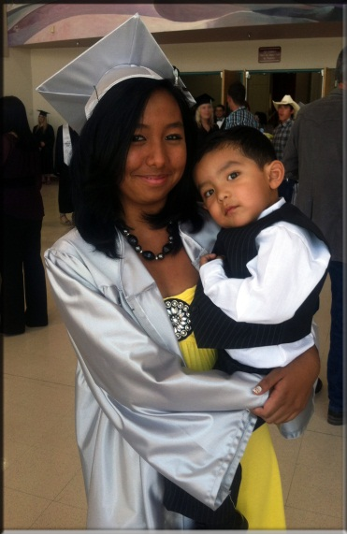
10 day excused absence for documented birth of child

4 excused absences, per semester, for expectant and parenting students when pregnancy or caring for a child necessitates missing class (supplementing general absence policy)

All absences will be documented, all work will be made up (students will allowed an equal number of days to make up work as they were absent from school)

Students will be responsible for notifying appropriate school personnel of their expectant or parenting status, should they choose to disclose this information

The Issue

Expectant and parenting students are balancing their responsibilities as parents and as students, working hard so they can provide for themselves and their families in the future. Unfortunately, inflexible school absence policies in New Mexico have been a major reason such students drop out of school. Students occasionally miss class because of the serious demands of parenting, including the need to go to pre-natal doctor’s appointments, stay home when their children are sick, and keep up with well-child visits and vaccinations for their families. Excusing absences when pregnancy or parenting necessitates missing class allows parents to make up work and fulfill their educational requirements. The new law is designed to address these needs.

The New Law

There are two primary absence policies that the new statute requires of schools: (1) absence policies covering the birth of a child; and (2) absence policies covering general absences for expectant and parenting students that are unrelated to the birth of a child.

- Schools must provide at least 10 days of excused absences to students who are absent due to the birth of a child. This is in addition to the number of excused absences a student is already permitted during a semester. This applies to both mothers and fathers. When a student’s doctor deems it medically necessary for that student to be absent for more than 10 days, the school must excuse those additional absences as well. Students must be given the opportunity to make up any missed work during this time period and are allowed the same number of days to make up the work as the student missed.

- Schools must provide at least four additional excused absences per semester to expectant and parenting students whose absences are related to the care of their children. These four excused absences are in addition to the number of excused absences a student is already permitted. For example, if a school permits a student to have 10 excused absences before being dropped from a class, then an expectant or parenting student would be permitted 14 excused absences before being dropped if those absences are related to caring for their children. This applies to both mothers and fathers. Students must provide documentation indicating that the absence is due to parenting needs. Students must be given the opportunity to make up any missed work during this time period and are allowed the same number of days to make up the work as the student missed.

The new legislation reflects the minimum a school must provide to expectant and parenting teens. Schools offering more absences for the birth of a child and/or parenting/pregnancy related absences should continue these policies. The new law simply provides a baseline for what is required of school absence policies in New Mexico.

Additional Laws

While the New Mexico law is new, there are also existing laws that prevent discrimination against expectant and parenting students. Title IX is a federal law that prohibits discrimination on the basis of sex in schools. Federal regulations also prohibit discrimination on the basis of pregnancy or childbirth. More specifically, Title IX regulations state that at a minimum, schools must grant students leave related to pregnancy, child birth, and birth recovery for the time deemed medically necessary by the student’s physician. New Mexico’s new law expands upon these federally regulated Title IX protections. Accordingly, both state and federal law require that expectant and parenting students must be given the same opportunities in school as other students.

